FEATURE DESCRIPTIONS and ACTIVATIONS

CALL TRANSFER - Allows incoming calls to be transferred to another Camp Lejeune number

3-WAY CONFERENCE - Allows you to establish a three-way conference with either an incoming call or two calls you originate.

Call Transfers or Three-Way Conference

• While on an active call, flash the hook switch (you get a unique tone)
• Dial the seven (7) digit number the call is to be transferred to
• Upon hearing the ring back the transferring station can either:
- Hang up to complete the transfer, or...
- Wait for an answer, and flash the
hookswitch once to establish a
three-way conference

CALL FORWARD - Call forward allows incoming calls to your telephone number to be automatically forwarded to another telephone number of your choice. This feature can be applied to all calls or selectively to don't answer or busy calls

• Pick up the handset
• Dial feature code desired:
*71 - Call Forward All Calls
*94 - Call Forward Busy
*96 - Call Forward Don't Answer
• Dial the seven (7) digit number you wish to forward your call to.
• Hang up when you hear a confirmation tone

To Remove Call Forward
• Pick up the handset
• Dial feature code desired:
*72 - Call Forward All Calls - Cancel
*95 - Call Forward Busy - Cancel
*97 - Call Forward Don’t Answer –
Cancel
• Hang up when you hear a confirmation tone

LAST NUMBER REDIAL - The Last Number Redial feature allows you to redial your last called number.
• Pick up the handset
• Press the number sign (#) key twice or *73
• The last number you dialed will be automatically dialed by the system

CALL PARK - Places a call in a parked state so that it can be retrieved from another telephone

• To park a call, dial the Call Park feature code - *74
• To retrieve the parked call from a different telephone:
- Pick up the handset
- Dial the Call Park Retrieve feature
code - *75
- Dial the number against which the
call is parked

CALL PICK-UP - Allows you to answer incoming calls to another telephone in your office The ringing station must be a member of your call pick-up group in order to answer the incoming call with this feature

• Pick up the handset
• Dial the Call Pick-Up feature code - *76, you are connected to the call

RING AGAIN - When you are making a call and encounter a busy signal, this feature will cause the switch to notify you when the number is free by sending a distinctive ring to your phone. When you pick up the receiver the switch will redial the number called.

After encountering a busy signal:
• Flash the hookswitch (you get a unique tone)
• Dial the Ring Again feature code - *79
• Hang up after hearing a confirmation tone
• When busy station becomes idle, you will receive special ringing. When you lift the handset, the system will automatically dial the station
• To cancel Ring Again feature, lift the handset and dial the feature code - *79

SPEED CALL - Allows you to place internal or external calls by dialing a programmed one digit code.

To Program a Speed Call number:
• Pick up handset
• Dial the Speed Call Program feature code - *81
• Dial the speed call number (0 through 9) to be assigned
• Dial the number to be stored (up to 24 digits)
• Dial number sign (#), receive confirmation tone

To Use Speed Call:
• Pick up the handset
• Dial * and the one-digit code assigned to the number to be dialed

CALL HOLD - This feature allows the user to hold on call until either party goes on-hook. With on call on hold the user can place another call.

While on an active call:
Flash the hookswitch (you get a unique tone)
Dial the Call Hold Feature code *99 and hang up

To retrieve a held call
Pick up the handset
Dial the call feature code *99, you will be reconnected to the call

MALICIOUS CALL TRAP/TRACE - Allows a subscriber to hold a connection on the switch on a malicious call, enabling the call to be traced back to the originating party.

• Keep caller on line if possible
• Call PMO desk Sgt at 451-2556/2555 from another line
• If call has been terminated, dial *57 from same line immediately
• Call PMO at 451-2555/2556

Note: Results will be provided to only authorized officials.
*57 may not work from multiline phones and unique phone Systems

EMERGENCY NUMBERS

For EMERGENCIES that require the Fire Department, Ambulance, or Military Police, Dial 911 and give the following information:

- Name of requester
- Address of requester
- Address or location of emergency
- Nature of emergency

BASE SERVICE CODES

The Camp Lejeune switch will provide several common services by dialing the following 3 or 7-digit codes:

451-1113 Camp Lejeune Information

451-1114 Repair (Trouble Desk)

451-3000 Time & Temperature

911 Fire/Ambulance/Police/EOD

PASSWORD RESETS 451-1114
DIALING SCHEMES

TYPE OF CALL __________ Access & Number

DSN (AUTOVON)
CONUS Routine 94 + 7 Digits
Overseas 451-1113 Operator
Assisted

LONG DISTANCE
CONUS 99+ 1 + 10 Digits

International Direct
Dial 99 + 011 + Country Code
+ City Code
International Operator
Assisted 99 + 010 + Country Code
+ City Code

800 Toll Free 99+1+ 800 / 888 + 7 Digits

Credit Card 9 + 0 + 10 Digits
OR
99 + 1 +800 Carrier
Access Number

Off Base Local Dialing 99 + 7 Digits

Cherry Point DSN Access: 94 + 582 + 4 Digits

NADEP 94 + 451 + 4 Digits

On Base Calling 7 Digits

Incoming Calls No Change

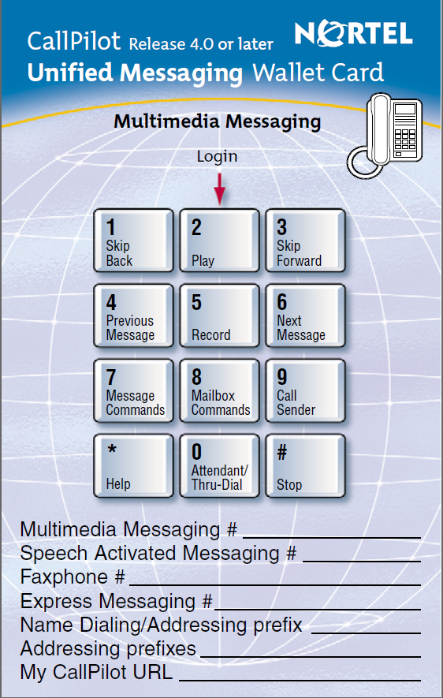

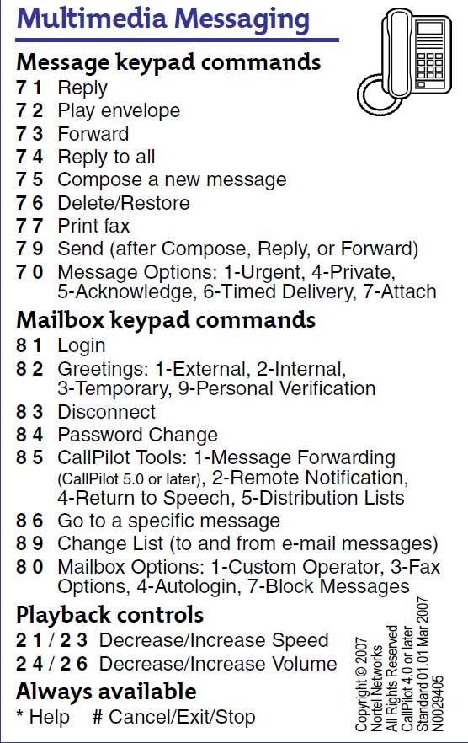
NEW 7 DIGIT DIALING PLAN BY LOCATION
Location Dial Plan
Hadnot Point 451-xxxx
H-1 451-xxxx
Hospital 450-xxxx
Camp Johnson 450-xxxx
Stone Bay Rifle Range 440-xxxx
Stone Bay Rifle Range 450-xxxx **
Courthouse Bay 440-xxxx
Courthouse Bay 450-xxxx **
New River Air Station 449-xxxx
Camp Geiger 449-xxxx
** Stone Bay and Courthouse Bay in the future
will all be changed to 440
NEW DSN PREFIXES
Dial Plan DSN Dial Plan
440 758
449 752
450 750
451 751

PASSWORD RESETS 451-1114 17-DEC-2008

LET'S TALK

A QUICK REFERENCE
FOR THE TELEPHONE
SYSTEM AT

MCB
CAMP LEJEUNE



Published By
Camp Lejeune
Telephone Branch

Telephone Problems/
Trouble Assistance
451-1114

